PROJECT DESCRIPTION:

This project aims to create an automated system that employs Optical Character Recognition (OCR) technology to extract Profit and Loss (PnL) values from images stored in a designated directory based on the image download date. The process involves utilizing image processing techniques and OCR algorithms to extract textual financial data, associating each PnL value with its respective image download date. The extracted data is then stored in a MySQL database for persistence, linking each PnL value to its corresponding download date. A backend system manages image uploads, performs OCR, associates PnL data with download dates, and stores it in the database. The React-based frontend enables users to interact with the system and visualize PnL information based on their corresponding dates through graphical representations. The deployment phase ensures both the backend and React frontend are hosted for seamless user access, streamlining the extraction, association, and visualization of PnL data according to image download dates.

1. UPLOADING THE IMAGES

This module includes an automated process that organizes screenshot images into their respective folders based on their trading apps such as 5Paisa and Finvasia. The system is designed to automatically sort and place the downloaded screenshot images into designated folders corresponding to their dates and trading app. This functionality streamlines the organization of the images, ensuring each image is stored in the folder that corresponds to the date it was downloaded or created.

FINVASIA FOLDER:
In this folder, the captured screenshots of Finvasia are uploaded. Whenever a screenshot is taken, an automated process immediately uploads the image into the designated folder, ensuring prompt organization based on the exact time and date of the screenshot capture. This system instantly sorts and stores the screenshots, allowing for efficient retrieval and subsequent processing for tasks like Optical Character Recognition (OCR) and financial data extraction.

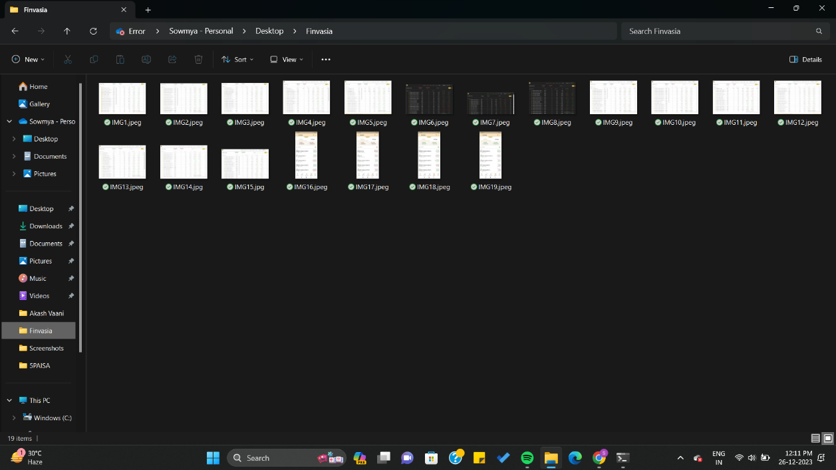

5PAISA FOLDER:
In this folder, the captured screenshots of 5Paisa are uploaded. Upon capturing a screenshot, an automatic process transfers the image to its allocated folder, ensuring precise categorization based on the exact moment of the screenshot's creation.

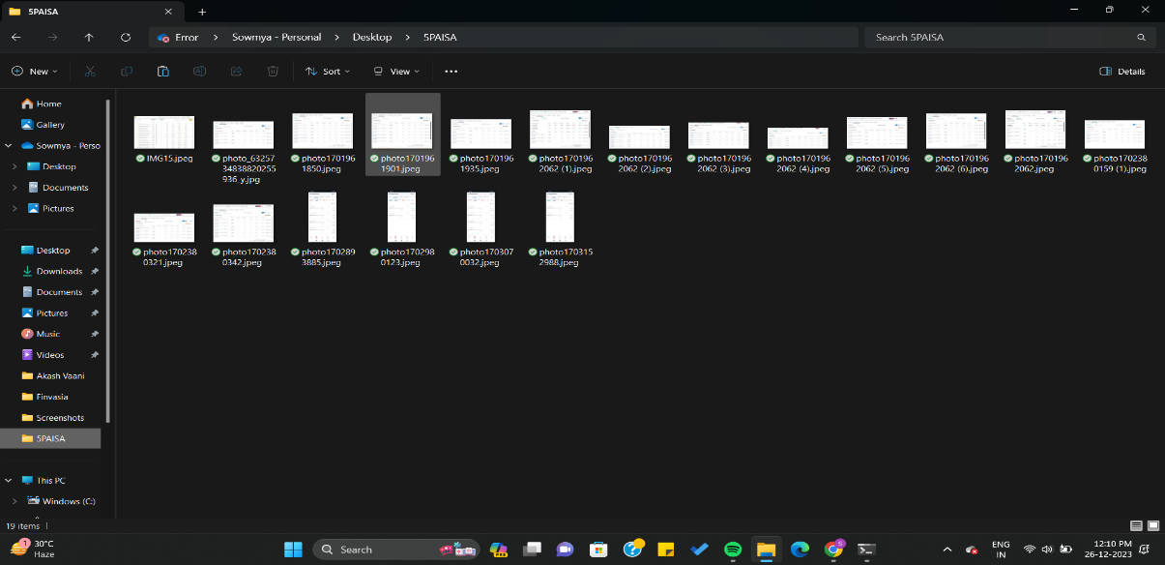

2. OPTICAL CHARACTER RECOGNITION ( OCR )

OCR is used to automate the extraction of Profit and Loss (PnL) values from images located within a specified directory.
LIBRARIES USED :
- os : Python library for interacting with the operating system, used for file handling and path operations.
- time : Standard Python library for time-related functions, utilized for time-based operations and delays.
- PIL (Python Imaging Library) or Pillow: Library used for image processing tasks such as opening, manipulating, and analyzing images.
- pytesseract : Python wrapper for Google's Tesseract-OCR Engine, employed for extracting text from images using OCR.
Utilizing Python libraries such as Pillow (PIL) for image processing and Pytesseract for Optical Character Recognition (OCR), this script continuously monitors the designated folder for new image files, capturing their modification timestamps and promptly analyzing them for financial data. Upon identifying a suitable image, the script extracts a defined region of text using specified coordinates and applies regular expressions to isolate the PnL values within the extracted text. Once the PnL values are successfully extracted, they are associated with their respective image modification times and stored in a MySQL database. The code operates in a loop, continuously scanning for new images, enabling real-time extraction and storage of PnL data, facilitating further analysis and reporting within financial applications. Additionally, error handling functionalities have been implemented to manage potential issues during data extraction and database insertion processes, ensuring the robustness and reliability of the system.

FINVASIA :
import os
import time
from PIL import Image
import pytesseract
import re
from datetime import datetime
import mysql.connector
pytesseract.pytesseract.tesseract_cmd = r'D:\tesseract\tesseract.exe'
folder_path =r"C:\Users\sdsow\OneDrive\Desktop\5PAISA"
specified_region_coordinates = (0, 0, 500, 500)
processed_files = set()
db_config = {
'host': '178.63.152.236',
'user': 'blaze',
'password': 'blaze.ws',
'database': 'output'
}
conn = mysql.connector.connect(**db_config)
cursor = conn.cursor()
def extract_value_from_image(image):
cropped_img = image.crop(specified_region_coordinates)
text = pytesseract.image_to_string(cropped_img)
matches = re.findall(r'[-+]?\b\d{1,3}(?:,\d{3})*\.\d{2}\b', text)
if matches:
pnl_value = matches[0].replace(",", "") # Remove commas
return pnl_value
return None
def get_image_modified_time(file_path):
if not os.path.isfile(file_path):
print(f"File {file_path} does not exist.")
return None
modified_time = os.path.getmtime(file_path)
modified_time_str = datetime.fromtimestamp(modified_time).strftime('%Y-%m-%d %H:%M:%S')
return modified_time_str
def process_new_images():
global processed_files
while True:
for filename in os.listdir(folder_path):
file_path = os.path.join(folder_path, filename)
if os.path.isfile(file_path) and filename.lower().endswith(('.png', '.jpg', '.jpeg', '.avif')):
if file_path not in processed_files:
img = Image.open(file_path)
modified_time = get_image_modified_time(file_path)
pnl_value = extract_value_from_image(img)
if pnl_value:
print(f"File: {filename}, Modified Time: {modified_time}, P&L Value: {pnl_value}")
try:
insert_query = "INSERT INTO 5paisa (filename, modified_time, pnl_value) VALUES (%s, %s, %s)"
cursor.execute(insert_query, (filename, modified_time, pnl_value))
conn.commit()
except mysql.connector.Error as err:
print(f"Error inserting data into MySQL: {err}")
processed_files.add(file_path)
time.sleep(10 )
process_new_images()

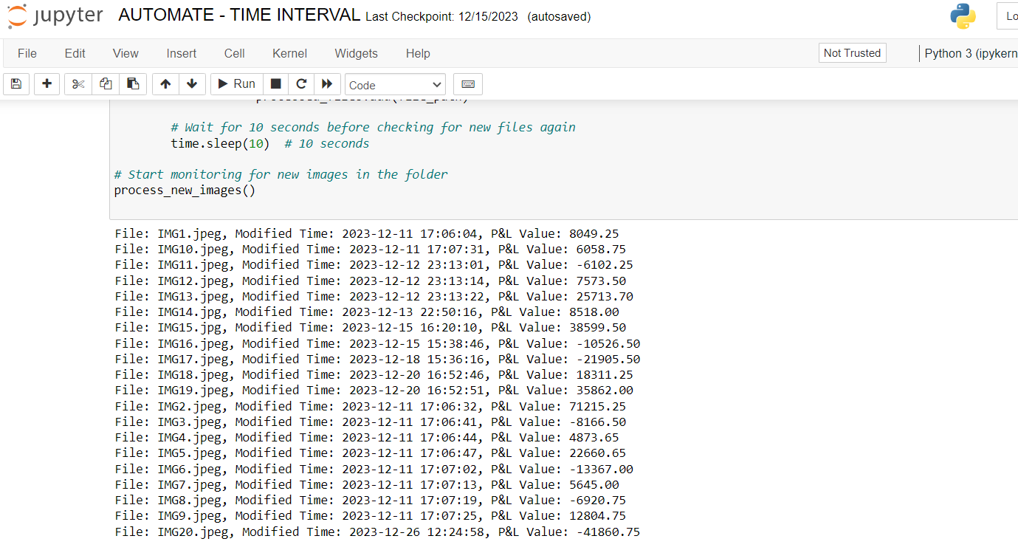

5PAISA :
import os
from PIL import Image
import pytesseract
import re
from datetime import datetime, timedelta
import mysql.connector
import time
pytesseract.pytesseract.tesseract_cmd = r'C:\Program Files\Tesseract-OCR\tesseract.exe'
mysql_config = {
'host': "178.63.152.236",
'user': "blaze",
'passwd': "blaze.ws",
'database': "output"
}
try:
conn = mysql.connector.connect(**mysql_config)
cursor = conn.cursor()
print("Connected to MySQL!")
except mysql.connector.Error as e:
print(f"Error connecting to MySQL: {e}")
exit()
folder_path = r"C:\Users\Keerthana Mahathi\Documents\5paisa"
specified_region_coordinates = (0, 0, 500, 500)
processed_files = set()
def extract_value_from_image(image):
# Use pytesseract to extract text from the specified region in the image
cropped_img = image.crop(specified_region_coordinates)
text = pytesseract.image_to_string(cropped_img)
matches = re.findall(r'([-+]?\d{1,3}(?:,\d{3})*\.\d{2})', text)
if matches:
return matches[0] # Return the first match (including sign)
return None
while True:
files_in_folder = os.listdir(folder_path)
new_files = [filename for filename in files_in_folder if filename not in processed_files]
for filename in new_files:
file_path = os.path.join(folder_path, filename)
if os.path.isfile(file_path) and filename.lower().endswith(('.png', '.jpg', '.jpeg', '.avif')):
img = Image.open(file_path)
modified_time = datetime.fromtimestamp(os.path.getmtime(file_path)).strftime('%Y-%m-%d %H:%M:%S')
pnl_value = extract_value_from_image(img)
insert_query = "INSERT INTO 5paisa (filename, modified_time, pnl_value) VALUES (%s, %s, %s)"
data = (filename, modified_time, pnl_value)
try:
cursor.execute(insert_query, data)
conn.commit()
print(f"Data inserted for File: {filename}")
except mysql.connector.Error as e:
print(f"Error inserting data for File {filename}: {e}")
processed_files.add(filename)
time.sleep(10)
cursor.close()
conn.close()

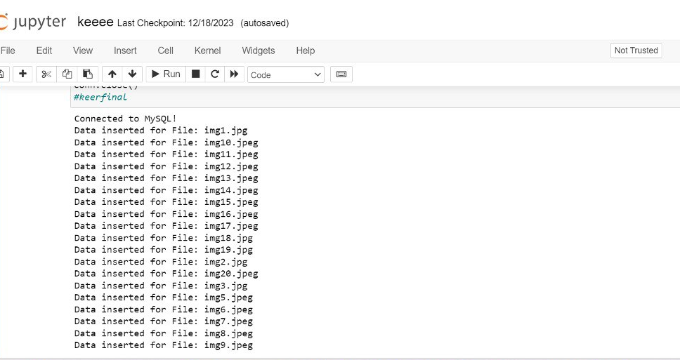
3. DATABASE STORAGE

The system is designed to employ MySQL as the database management system, utilizing distinct tables to segregate and store essential data related to various trading applications. Each table within the MySQL database corresponds to a specific trading app and accommodates information such as the filename of the associated image, the timestamp of the image's modification, and the extracted Profit and Loss (PnL) values. This structured approach allows for a clear and organized arrangement of financial data. By utilizing MySQL's relational database capabilities, this architecture optimizes data retrieval, analysis, and reporting processes, facilitating efficient access to specific PnL data sets based on trading app categories. Whenever a new image is uploaded, the system instantly initiates the extraction process. These extracted data points are stored in corresponding tables within the MySQL database corresponding to their respective trading applications. This automated workflow ensures that as new images are added, their financial data is promptly processed, facilitating real-time updates and ensuring accurate storage in MySQL for each trading app's specific analysis and reporting requirements.

FINVASIA : 5PAISA: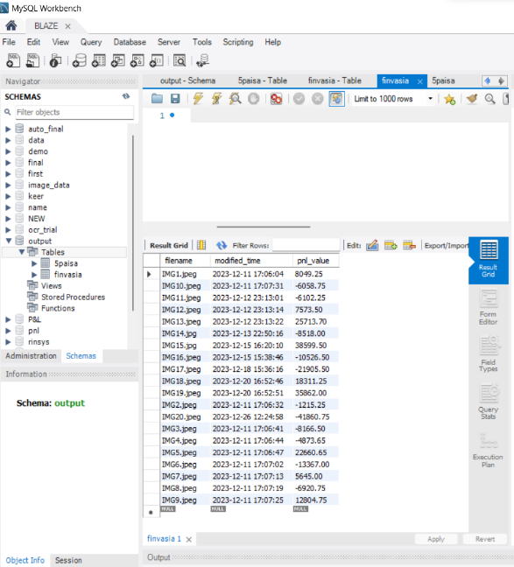 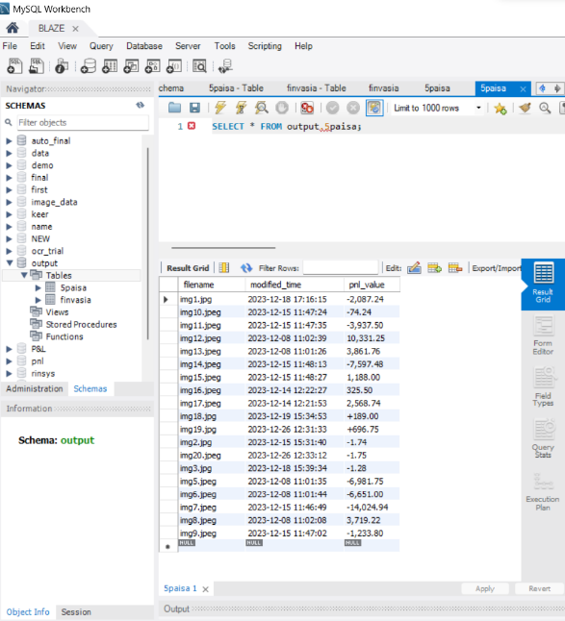

4. REDASH

Redash is a powerful and versatile data visualization and exploration tool designed to simplify the process of transforming raw data into meaningful insights. As a web-based business intelligence platform, Redash facilitates seamless connections with various databases. Its user-friendly interface and robust features make it an indispensable tool for teams and individuals seeking to analyze and communicate data-driven findings effectively.
Its seamless integration with databases coupled with an intuitive query editor, caters to diverse data analysis needs. The platform's diverse visualization widgets contribute to transforming complex data into easily interpretable insights along with capabilities for creating interactive dashboards and scheduling automated reports.
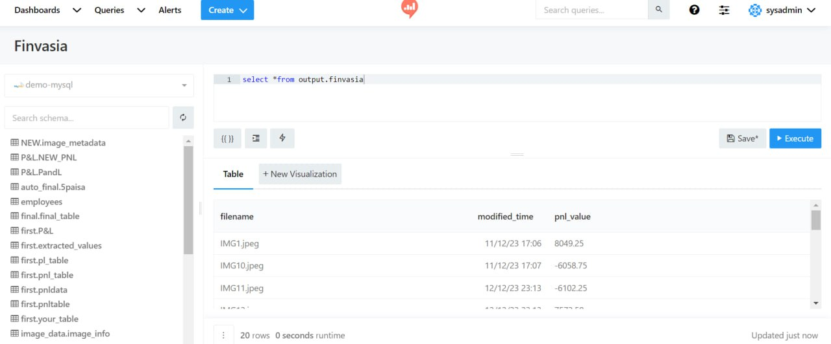

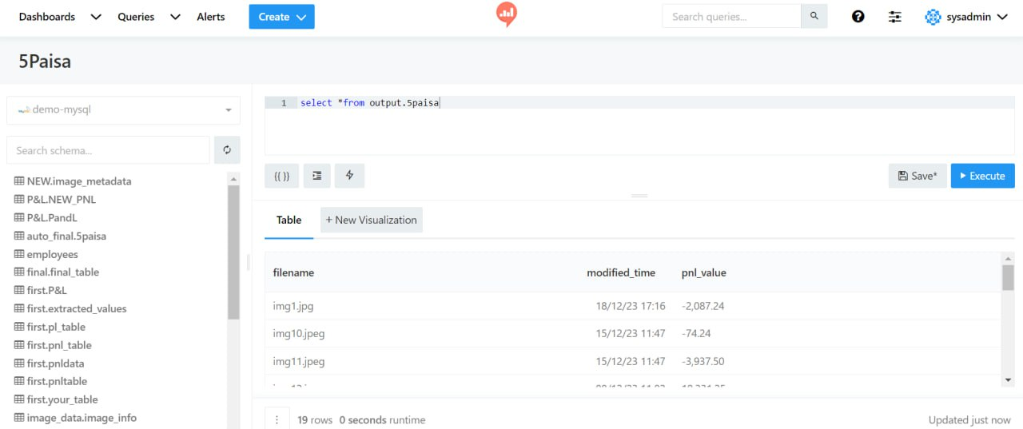
5. REACT WEBPAGE
The dashboard page offers users a straightforward interface to visualize and analyse Profit and Loss (P&L) values from their trading account screenshots taken automatedly. Beyond the conventional features, we prioritize user convenience by incorporating at-a-glance indicators within the P&L graphs, allowing users to quickly discern whether their shares are at a profit or loss and understand the direction of price movements without the need to log in to each account every time. This functionality, powered by React, connects with our backend Python scripts, MySQL database, and the Redash visualization tool, providing users with a practical and more informative experience.

